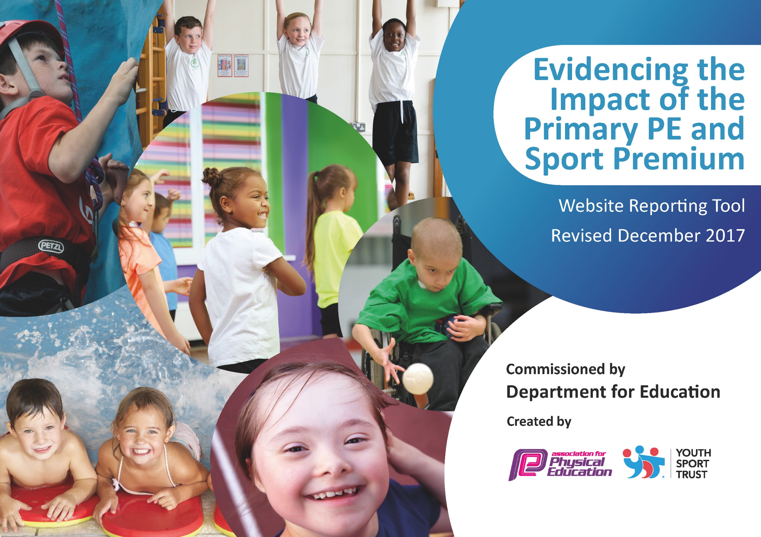

Schools must use the funding to make additional and sustainable improvements to the quality of PE and sport they offer. This means that you should use the Primary PE and Sport Premium to:

- develop or add to the PE and sport activities that your school already offers
- build capacity and capability within the school to ensure that improvements made now will benefit pupils joining the school in future years

Please visit gov.uk for the revised DfE guidance including the 5 key indicators across which schools should demonstrate an improvement. This document will help you to review your provision and to report your spend. DfE encourages schools to use this template as an effective way of meeting the reporting requirements of the Primary PE and Sport Premium.

We recommend you start by reflecting on the impact of current provision and reviewing the previous spend.
Under the Ofsted Schools Inspection Framework, inspectors will assess how effectively leaders use
the Primary PE and Sport Premium and measure its impact on outcomes for pupils, and how effectively governors hold them to account
for this.

Schools are required to publish details of how they spend this funding as well as on the impact it has on pupils’ PE
and sport participation and attainment.
We recommend regularly updating the table and
publishing it on your website as evidence
of your ongoing review into how you are using the money
to secure maximum, sustainable impact. To see an example of how to complete the table please click HERE.

Support for review and reflection - considering the 5 key indicators from DfE, what development needs are a priority for your setting and your students now and why? Use the space below to reflect on previous spend, identify current need and priorities for the future.

Key achievements to date: Oct 18 | Areas for further improvement and baseline evidence of need:
- South London Special League Champions  - Taking SEMH children to an athletics competition  - Pupil breaking LEA athletics record  - Pupils achieving Level 1 basic sailing  - Staff achieving level 1 sailing instructor certificates | - Pupil participation in wider variety of competitions  - PEG to train Horse riding instructor

Meeting national curriculum requirements for swimming and water safety | Please complete all of the below*:
What percentage of your current Year 6* cohort swim competently, confidently and proficiently over a distance of at least 25 metres? | 80%
What percentage of your current Year 6* cohort use a range of strokes effectively [for example, front crawl, backstroke and breaststroke]? | 50%
What percentage of your current Year 6* cohort perform safe self-rescue in different water-based situations? | 0%
Schools can choose to use the Primary PE and Sport Premium to provide additional provision for swimming but this must be for activity over and above the national curriculum requirements. Have you used it in this way? | No
*2017/18 Cohort

Action Plan and Budget Tracking
Capture your intended annual spend against the 5 key indicators. Clarify the success criteria and evidence of impact that you intend to measure to evaluate for students today and for the future.

Academic Year: 2017/18 | Total fund allocated: £15,800 | Date Updated: October 2018
Key indicator 1: The engagement of all pupils in regular physical activity |  |  |  | Percentage of total allocation:
 |  |  |  | 53.8%
School focus with clarity on intended impact on pupils: | Actions to achieve: | Funding allocated: | Evidence and impact: | Sustainability and suggested next steps:
Application of student voice identified and requested more outdoor/ adventure learning activities, including Boxing, Horse riding, water-sports, archery and ‘outward bound’ activities e.g Down activity centre.  Enhanced pupil enjoyment and improved behaviour enabling increased concentration levels towards afternoon sessions – building of pupil resilience, independence, self-esteem and confidence to impact on other areas of curriculum, with improved outcomes and progress.  Application of student voice identified and requested more outdoor/ adventure learning activities, including Horse riding, water-sports, archery and ‘outward bound’ activities e.g Down activity centre.  Enhanced pupil enjoyment and improved behaviour enabling increased concentration levels towards afternoon sessions – building of pupil resilience, independence, self-esteem and confidence to impact on other areas of curriculum, with improved outcomes and progress.  To provide pupils with opportunities to develop their cycling skills  To be safe to cycle on the road.  Cycling to be part of the active and healthy life time education program promoted by BTA | Pupils achieve identified SEMH targets and show increased levels of independence, resilience and a positive attitude to all areas of learning.  DJ/ PB to complete instructor training courses for climbing and sailing, resulting in future costs decreasing as will be able to lead on activities rather than hiring instructors,  Purchase of additional bikes to support Bikeability Sessions. | £6000  (Daily session per week cost £155 x38)  Indoor Climbing wall Instructor Course and assessment units £750.  Basic Dingy training and Sailing Skills training – Instructor training (3 units) £750  £1000 | 100% of pupils take part in 2hrs of physical activity a week.  Through Assessment systems that have been put in place and the improved quality of teaching and learning.  80% pupils have expected progress (3 points) from their starting points.  30% pupils passed basic sailing skills  25% pupils accessed horse riding  35% of pupils accessed outdoor adventurous activities  Bicycles purchased  85% of children able to ride a bike | Through Assessment systems that have been put in place and the improved quality of teaching and learning.  85% pupils have made expected progress (3 points) from their starting points.  Two Staff members have qualified as level 1 sailing instructors.  50% pupils take basic sailing.  PEG to train as horse riding instructor.  100% of children able to ride a bike.
Key indicator 2: The profile of PE and sport being raised across the school as a tool for whole school improvement |  |  |  | Percentage of total allocation:
 |  |  |  | 6.3%
School focus with clarity on intended impact on pupils: | Actions to achieve: | Funding allocated: | Evidence and impact: | Sustainability and suggested next steps:
Application of student voice identified and requested Team kits pupils to wear when representing the school at tournaments and competitions  Enhanced pupil enjoyment and improved behaviour enabling increased concentration levels towards afternoon sessions – building of pupil resilience, independence, self-esteem and confidence to impact on other areas of curriculum, with improved outcomes and progress. | Purchase team sports wear to where at competitions.  Set up tracker system for each child to track pupils behavior, attainment with sports attainment | £1000 | Increased number of children participated in intra & inter school sports competitions – 86% of all children participated in at least one event.  Increased range of competitions/ intra & inter school sports competitions (at least five different sports/ areas). | Increased number of children participated in intra & inter school sports competitions – 90% of all children participated in at least one event.  Increased range of competitions/ intra & inter school sports competitions (at least six different sports/ areas).

Key indicator 3: Increased confidence, knowledge and skills of all staff in teaching PE and sport |  |  |  | Percentage of total allocation:
 |  |  |  | 19%
School focus with clarity on intended  impact on pupils: | Actions to achieve: | Funding  allocated: | Evidence and impact: | Sustainability and suggested  next steps:
DJ completed level 5 Primary School Physical Education Specialism and Subject Leadership.  DJ now looking to extend this further through gaining a degree in PE and Sports, leading to outstanding teaching, leadership and management of subject / PESS Premium strategy with improved outcomes for pupils. | On site subject leader development | £3000 | DJ to complete Degree for Physical Education with further possible outcome of working with Bromley Collegiate and QTS  A sustainable legacy is continued to be built which will impact on children and young people.  Sustainable professional development.  Pupils receive a high standard of teaching and learning, and will create additional positive impact upon our school development plan outcomes.  80% pupils have expected progress (3 points) from their starting points.  85% plus of PE lessons are good, with 15-20% Outstanding | 100% PE lessons are good, with 25-50% Outstanding  2 Staff members have qualify as level 2 sailing instructors.  PEG to train as horse riding instructor
Key indicator 4: Broader experience of a range of sports and activities offered to all pupils |  |  |  | Percentage of total allocation:
 |  |  |  | 6.3%
School focus with clarity on intended  impact on pupils: | Actions to achieve: | Funding  allocated: | Evidence and impact: | Sustainability and suggested  next steps:
Improved resourcing for sport-specific activities.  Differentiated equipment sourced to accommodate various pupil needs  Enhanced pupil enjoyment and improved behaviour enabling increased concentration levels towards afternoon sessions – building of pupil resilience, independence, self-esteem and confidence to impact on other areas of curriculum, with improved outcomes and progress. | Improved resourcing for sport-specific activities | £1000 | Ongoing monitoring of equipment state to ensure that resources do not fall into a state of disrepair  Audit of PE & Sports equipment to ensure that all areas are sufficiently resourced to provide a breadth and depth to PE curriculum.  80% pupils have expected progress (3 points) from their starting points.  85% PE lessons are good, with 15-20% Outstanding | Annual audit of PE & Sports equipment to ensure that all areas are sufficiently resourced to provide a breadth and depth to PE curriculum.  100% PE lessons are good, with 25-50% Outstanding  Through Assessment systems that have been put in place and the improved quality of teaching and learning.  85% pupils have expected progress (3 points) from their starting points.
Key indicator 5: Increased participation in competitive sport |  |  |  | Percentage of total allocation:
 |  |  |  | 14.6%
School focus with clarity on intended  impact on pupils: | Actions to achieve: | Funding  allocated: | Evidence and impact: | Sustainability and suggested  next steps:
Access to SGO organised borough primary competition Activities  Raise pupil participation levels within sport-specific inter competitions  Pupils able to participate in, and have a broader range of physical activity experiences | Subscription to Borough SGO inter competition package  Subscription to South London Special league | £250  + £50 Athletics  Total £300  + Supply day release  to address supervision of school teams at borough SGO and South London Special league led daytime inter competition events  £2000 | Increased number of children participating in intra & inter school sports competitions – 80% of all children to participate in at least one event. (Had been achieved last year for KS2, need to focus on KS1)  Increased range of competitions/ intra & inter school sports competitions (at least five different sports/ areas). | Increased number of children participated in intra & inter school sports competitions – 90% of all children participated in at least one event.  Increased range of competitions/ intra & inter school sports competitions (at least six different sports/ areas).

