End of topic quiz

Topic B1: Cell level systems

Learner Activity

Topic: B1 of J247
Total marks: 40

1. | Which of the following are all polymers? [1 mark]
 | A | DNA, protein and glucose
 | B | DNA, protein and starch
 | C | Amino acids, nucleotides and glucose
 | D | Amino acids, nucleotides and starch
 | Your answer

2. | Lipase is an enzyme that is made in the pancreas and breaks down lipids into fatty acids and glycerol.  The diagram shows a schematic representation of a lipid.  Which diagram below represents the enzyme lipase? [1 mark]
 | A
 | B
 | C
 | D
 | Your answer

3. | The concentration of carbon dioxide in the air around a plant changes throughout the day.  This is due to processes inside the plants.  The graph shows the overall volume of carbon dioxide taken up and given out by plants throughout the day.  Which statement correctly explains the increase in the volume of carbon dioxide taken up by the plant between 04:40 and 20:30? [1 mark]
 | A | The plant is photosynthesising only
 | B | The plant is respiring only
 | C | The rate of respiration in the plant is higher than the rate of photosynthesis.
 | D | The rate of photosynthesis in the plant is higher than the rate of respiration.
 | Your answer
4. | What type of reaction is cellular respiration? [1 mark]
 | A | Hydrolysis
 | B | Exothermic
 | C | Neutralisation
 | D | Endothermic
 | Your answer
5. | Plants make glucose during photosynthesis.  In what form do plants store this sugar for use at a later time? [1 mark]
 | A | Glucose
 | B | Cellulose
 | C | Protein
 | D | Starch
 | Your answer
6 | Living organisms are made up of cells.  Microscopes can be used to view cells.  The image shows a light microscope.  A  B
 | (a) |  | (i) | Name the parts of the microscope labelled A and B. [2 marks]
 |  |  | (ii) | Why do scientists sometimes use stains such as iodine when they make slides of specimens? [1 mark]
 | (b) |  |  | Microscopes produce a magnified image of a specimen.  To calculate how much bigger the image is than the specimen, we use this formula:  magnification = length of image  length of specimen  The diagram below (not to scale) shows an onion cell slide and the microscope image of an onion cell.  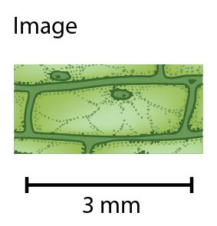  The magnified image is 3 mm wide.  The specimen is 0.05 mm wide.  Calculate the magnification. [1 mark]

7 | Cells are made up of many sub-cellular structures.  The diagram shows a plant cell.  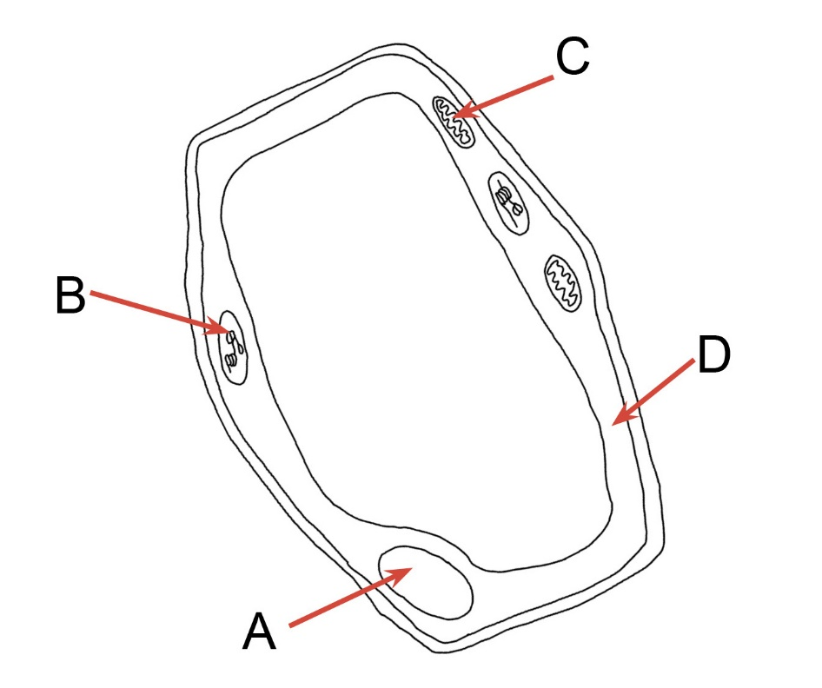
Four sub-cellular structures have been labelled A, B, C and D on the diagram.
In the table below add the appropriate letter to the correct function of the
sub-cellular structure it indicates. [4 marks]
Definition |  | Letter
contain enzymes for cellular respiration
contains genetic material
where photosynthesis takes place
contain receptor molecules and provides a selective barrier to molecules

8 | DNA is found in the nucleus of cells and controls the inherited characteristics a person has.  The picture shows part of a DNA molecule.
 | (a) | (i) | State the name given to the shape of a DNA molecule. [1 mark]
 |  | (ii) | 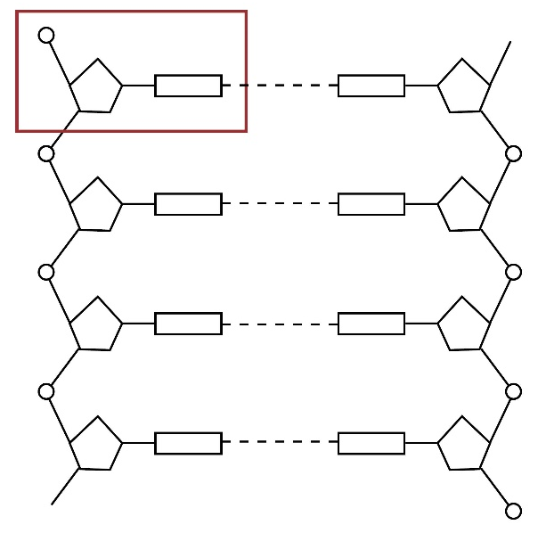  A DNA molecule is made up of smaller subunits as shown in the diagram.  One of these subunits has been circled in the diagram.  What is the name of one of these subunits? [1 mark]
 |  | (iii) | These subunits are made up of a base and two other components.  Name the two other components. [1 mark]
 | (b) | (i) | DNA contains four different types of bases: guanine (G), cytosine (C), adenine (A) and thymine (T).  Two bases bind together, joining the two strands of DNA.  The diagram shows a section of DNA.  Nine bases on one strand are shown in the diagram.  Complete the second strand on the diagram to show the nine complementary bases. [1 mark]
 |  | (ii) | How many amino acids would this section of DNA code for? [1 mark]
 | (c) |  | Higher only  The sequence of bases in the DNA molecule code for the production of proteins.  Describe the process of protein synthesis. [5 marks]
9 | Amylase is an enzyme that breaks down starch.  An experiment is done to find the effect temperature has on the action of amylase.  Iodine is used to show when the starch has been fully broken down by the amylase..  The results table is shown:  Temperature (ºC) Time taken (minutes) Rate of reaction (cm³/minute)  10 11.0 0.9  20 6.5  30 3.0 3.3  40 1.0 1.0  50 12.0 0.8
 | (a) | (i) | The rate of reaction can be calculated by dividing the volume of starch (10 cm³) by the time taken for the starch to be broken down.  For example at 10 ºC: 10/11 = 0.9 cm³/min  Calculate the rate of reaction at 20 ºC. [1 mark]
 |  |  | ............................... cm³/min
 |  | (ii) | Using the data from the table, what is the optimum temperature of amylase?  [1 mark]

 | (b) | (i) | Explain why the reaction slows at lower temperatures. [2 marks]
 |  | (ii) | After 180 seconds the starch had not been broken down at 50 ºC.  Explain why the enzyme does not break down starch at this temperature.  [1 mark]
 | (c) |  | Explain why amylase will not speed up the breakdown of proteins into amino acids. [3 marks]

10 | All living things need energy to survive.  Energy is released in living cells by a process called respiration and is used to make ATP.  The table shows the similarities and difference between the substrates and products of the different types of respiration.  Aerobic respiration Anaerobic respiration in fungi (e.g. yeast) Anaerobic respiration in animals  Substrates Glucose Glucose  Products Carbon dioxide and water
 | (a) | (i) | Complete the table to show the substrates and products for the different types of respiration. [3 marks]
 |  | (ii) | Describe the relative yields of ATP produced in aerobic respiration compared with anaerobic respiration. [1 mark]

11 | Heidi is investigating the effect of light intensity on the rate of photosynthesis.  She does this by placing a lamp at various distances from a boiling tube containing a 10 cm long piece of pondweed and 100 cm³ of water. The closer the lamp, the higher the light intensity.  She counts how many bubbles of gas given off in two minutes by the pondweed.  She repeats the experiment at each distance three times and calculates the average number of gas bubbles in a table:  Distance from the lamp (cm) Number of gas bubbles  20 49  30 26  40 11  50 8  60 7
 | (a) | (i) | What gas is in the bubbles given off by the pondweed? [1 mark]
 |  | (ii) | Describe the relationship between light intensity and the rate of photosynthesis as shown in the table. [1 mark]
 |  | (iii) | Would you expect this relationship to continue if Heidi continued to increase the light intensity? Explain your answer. [2 marks]
 | (b) |  | State one way Heidi could measure the rate of photosynthesis more accurately than counting the number of bubbles produced. [1 mark]

