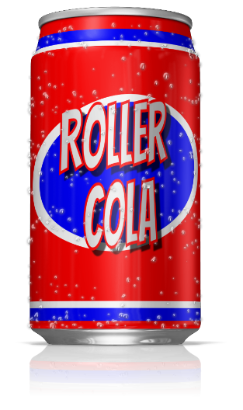
Roller Cola* is a budget, cola-flavoured, carbonated soft drink that is sold in 330ml cans (pictured). Once the UKs biggest selling budget soft drink, it has seen sales fall steadily, and its future is now in doubt. The managers at Roller Refreshment*, the manufactures of Roller Cola, are keen to keep the product, but recognise that they need to do something.
Product Life Support
NAME:
Task 1
The managers at Roller Refreshment know that there are a number of ways in which the life of Roller Cola can be extended. They would like you to outline some ideas for each of the methods outlined in the table below:
Methods of Extending the Life of a Product |  | Product Extension Ideas
1) | Advertising
2) | Changing the price
3) | Adding Value
4) | New Markets
5) | New Packaging
The names “Roller Cola” and “Roller Refreshments” are fictional. Any resemblance to actual products or businesses is unintentional and coincidental
Task 2
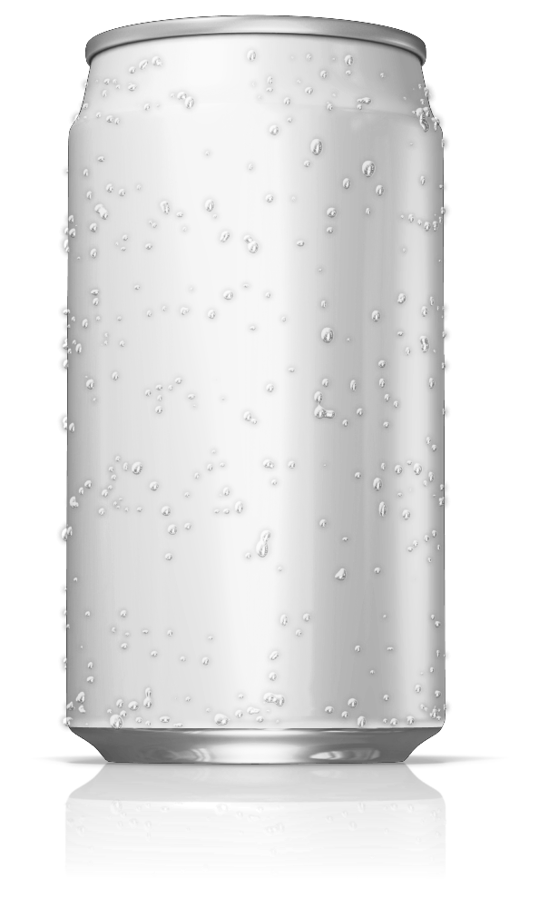
The managers are interested in your ideas for redesigning the packaging. They believe that they could combine this with some of your other ideas. They have asked you to design an alternative design for their current 330ml can, so they can see what it might look like. They are happy for you to include one of your other ideas into the design:

