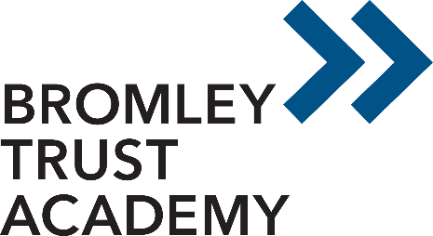
Bromley Trust Academy - Hayes Campus
Hayes Lane,
Bromley
BR2 9EA
telephone: 020 8290 0274
Head of School: Emily Richards

24th April 2023
Dear Parent/ Carer,
As you may have seen on the news, members of the largest teaching union (the NEU) have voted to take further national strike action over the coming weeks after rejecting the latest pay offer from the government.

This will affect over 23,000 schools across the country – including our own – with teachers who are members of the NEU expected to strike. Any staff member not part of the NEU will be attending school as usual.

National strikes are currently planned for 27th April and 2nd May.

As a school, we respect our staff’s right to strike but will be doing our very best to minimise the impact that this action has on pupils.

Our contingency plan for the two planned days of strike action includes a partial closure of the school to ensure we continue to operate in line with health and safety regulations. As a result of this, your child will be expected in school on Thursday 27th April and Tuesday 2nd May. The school will be open to your child in line with normal school hours (8.50am – 2.55pm). Your child will be expected in full uniform and we will be providing break time and lunch time food. We will keep you updated in regards to the other planned strike days.

Please do rest assured that ensuring our pupils are safe and cared for is our main priority. If you do have any worries or concerns, don’t hesitate to contact Emily Richards on Emily.bennett@bromleytrust.lseat.org.uk or 0208 290 0274.

As with all planned strikes, things can change in the lead up to the action. We will keep you updated on any information we receive.

Yours faithfully,

Emily Richards
Head of School
Bromley Trust Academy Hayes

