Aim: To be able to create a voice through my writing.

A good writer is like a good actor. They can produce characters so believable that the reader can recognise them just by the way they speak and act.
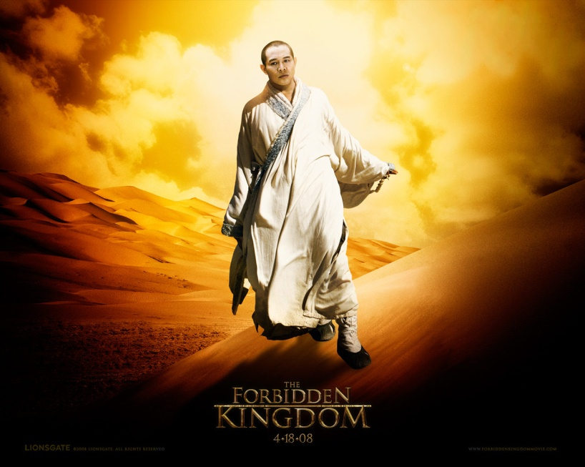
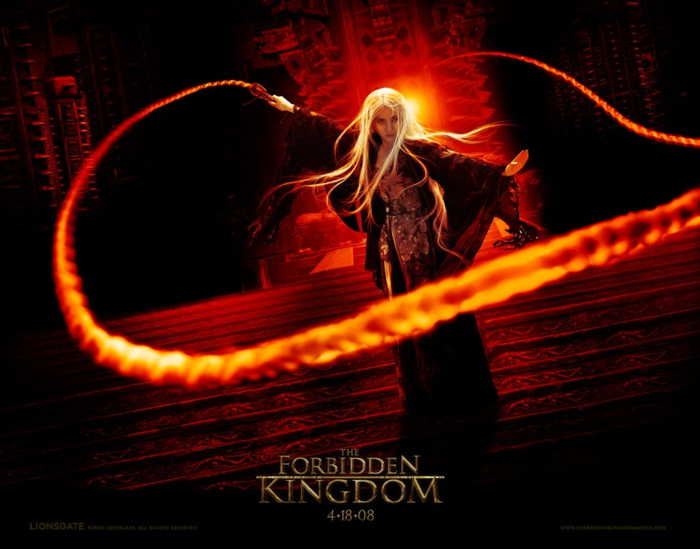
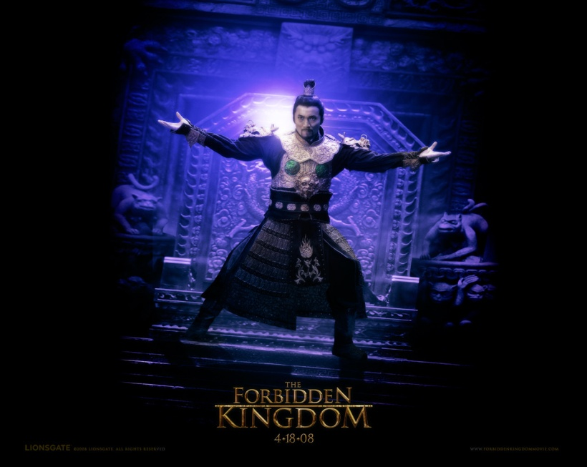
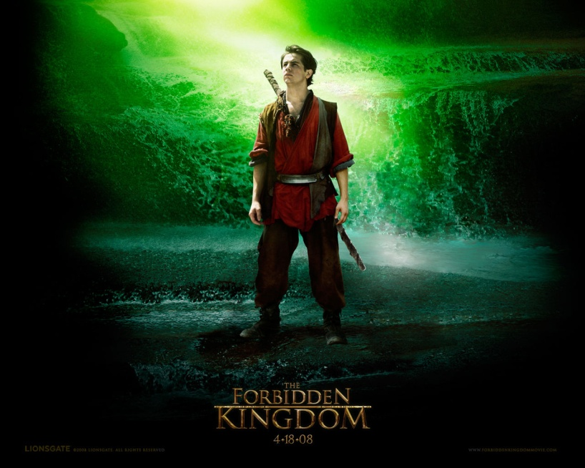
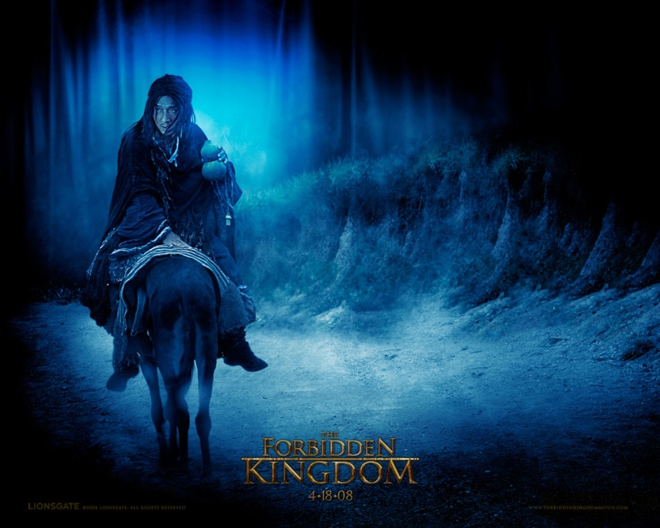
Task 1: Look at ‘The Forbidden Kingdom’ pictures below and answer the questions.

- What gives the reader clues that ‘The Silent Monk’, Lu Yan, Jason and ‘Golden Sparrow’ are the good characters and that Ni Chang and the Jade Warlord are evil characters?
- For each character, state one quality that the reader learns about them from their picture (what they do, what sort of personality they have etc.)

Task 2: Choose two of these characters.
- For each one, list what you could do with your writing to try and reflect their personality. You could use some of the writing techniques in the table below to help (you can think of other ideas as well).
The character could communicate more in action than in speech | The character could use long descriptive sentences | The character could use a lot of questions showing that they do not understand | The character could speak using imperatives (commanding words) to show they are ‘the boss’
The character could speak loudly | The character could speak quietly/softly | The character would always be serious | The character could be humorous at times
The character could get on well with other characters | The character could argue or upset other characters | The character’s gracefulness could be emphasized | The character’s power could be emphasized
Animal metaphors and similes could be used to describe the character | ‘Dark’ metaphors and similes could be used to describe the character | The character could speak using short sentences | Use repetition to emphasize the character’s speech or action
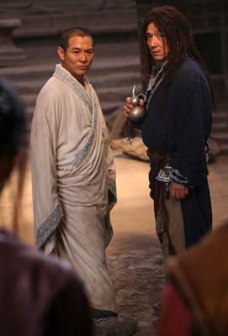
- For each of the writing techniques you have used in the last task, state why you think the technique would reflect the character well.
- If a character is mainly serious, why do you think it would be a bad idea to have them do something funny? What would the reader think?

Task 3: You are going to write a script, at least one page long, showing a dialogue (two or more characters talking) between your two chosen characters from the last task. Remember that you are aiming to make the characters sound believable through what they say and any stage directions you use.

Task 4: In groups of four you will perform your scripts. Each script should be read and each person should take the role of a character at least once. This is how the presentations should be carried out:
- Two members of the group should read the script (they will not have to read the stage directions)
- The other two members will listen and make notes on what they think about the character, what they think went well and what could be improved

Extension: You are Hercules about to deliver a story about how you saved a village from a terrible monster. Decide how you will reflect the character of Hercules in your writing and write a monologue.

