Aim: To examine the appeal of myths to a modern audience.

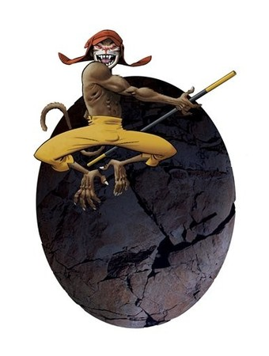
Task 1: Look at the character on the left. Based on the picture what sort of character do you think this is? Think about what the character looks like, the expression on his face and what he is holding.

Task 2: The character on the left is from Chinese mythology. In English he is generally called ‘Monkey’ or ‘The Monkey King’, but in Chinese his name is ‘Sun Houzi’. The box below tells the story of this character. Read the story.
Task 3: The pictures of Monkey on this page seem to present him as a young character. Why do you think, based on the story of Monkey, he is presented this way?
Monkey was supposedly born from a stone egg, created from a rock as old as time and the essences of Heaven and Earth. He was a master of magic, and his weapons included a magical staff capable of growing or shrinking to any size.
Monkey defied the supreme god of Chinese mythology, the Jade Emperor (Yu Di), by claiming to be a high god. To appease the mischievous Monkey, the Jade Emperor proclaimed him King of Heaven, concealing the fact that he had only made him a heavenly stable keeper. Monkey discovered this deception and, enraged, returned to Earth to wreak havoc. The Jade Emperor asked Buddha for help. Buddha dropped a mountain on Monkey, and Monkey remained beneath it for 500 years. On his journey from China to India to retrieve Buddhist scriptures, a monk called Tripitaka unearthed Monkey, who became Tripitaka's escort and disciple. With two other companions, Piggy and Sandy, both exiled from the Heavenly Court reborn in monstrous bodies, Monkey accompanied the monk for 14 years, covering nine kingdoms and encountering numerous fantastic adventures. After presenting the scriptures Tripitaka had obtained in India to the Chinese emperor in the imperial capital of Chang-an, the four travellers were borne up to heaven. Monkey, with his irrepressible spirit and countless magic tricks, is generally regarded as a personification of the nature of genius.

Task 4: An animated version of one of Monkey’s adventures was used as the opening to the 2008 Olympic Games in China. If your teacher shows you this animation answer the following:
- What tells the audience that these Olympic Games are being held in China?
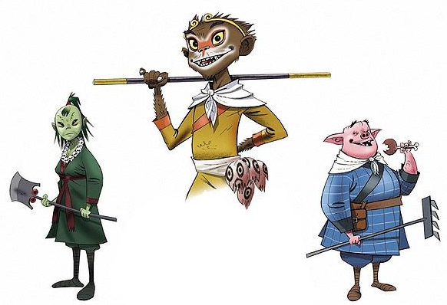
- List as many of the Olympic sports/events that you can see represented in the animation.
- Why do you think this animation would encourage adults and/or children to watch these Olympic Games?

Task 5: Design an animal creature to represent the London 2012 Olympic Games. Try to use an animal that is found in this country or that represents the spirit of Britain.
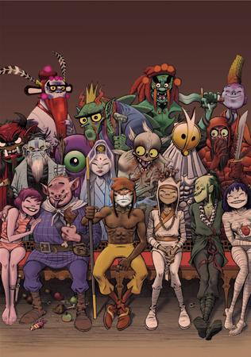
Task 6: On the left is a picture showing Monkey and some of the other characters from his myth. Choose one of the characters that have been indicated, think of a name for them, and give a brief summary (like the Monkey story) of what they are like and why they are like this. Also, explain what their personality is like.

Task 7: The picture on the left has been drawn in a modern style. Do you think that this style of artwork suits the myth or not? Give reasons for your answer.
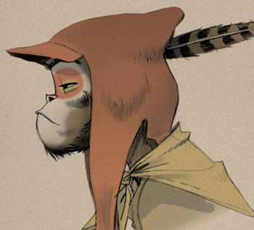

Task 8: Below is a model based on the character of Monkey. Make the model.

