Aim: To be able to understand and respond to themes and ideas from texts.

Even the earliest stories have tried to convey themes and ideas to the reader. Many of these themes and ideas have proven so popular that the stories still exist today.

Task 1: In the box below is the story of Persephone. Persephone is from Greek mythology and was the daughter of Demeter (who was God of the Harvest). Read the story and answer the questions below…
In the days when gods and goddesses walked on the Earth, the three most powerful gods were brothers. Zeus was ruler of the sky, Poseidon was god of the sea and Hades was the Lord of the Underworld.

The Underworld was a terrible place, a place without light, where the spirits of the dead went. Having entered the underworld, and having eaten there, no-one was allowed to re-enter the world of the living.

A beautiful girl lived on the Earth and her name was Persephone.

One day Hades visited Earth and rode past Persephone while she was gathering flowers in a field. He was dazzled by her beauty. He wanted her. And being one of the three most powerful gods, he kidnapped her and drove off in his chariot.

Persephone was terrified. She was pinned to the floor of Hades' chariot while he drove faster and faster, down and down, into the darkness of the underworld. In the black halls of Hades, Persephone crouched and cried, refusing all food, refusing to speak to the god who had snatched her away. Days passed. Persephone's hunger grew. At last she could resist no longer, she ate some pomegranate seeds and, having eaten, she could not return to the world above.

Meanwhile, her Mother, the goddess Demeter, grew distracted. She knew what had happened but she could do nothing. She raged all the more because she was powerless against Hades. She went to Zeus, the king of gods, and she begged him to bring about Persephone's return. Zeus could not bear Demeter's crying. Her tears were destroying the harvest. He had to do something.

Unfortunately, he was too late to stop Persephone eating the Pomegranate seeds. The rules of the Underworld had to be obeyed. Yet, Zeus being Zeus, the rules could be stretched a little. He sent Hermes, the messenger of the gods, to strike a deal with Hades. The deal was this. Persephone would marry Hades and remain Queen of the Underworld, living there half the year. In the spring she could return to earth, and live there in the warm, bright light of the summer.

And this is what happened. While Persephone lives in the underworld, the days are short and dark and cold. But with her return to Earth in the spring, the flowers start to bloom, the leaves to bud, and the birds to sing in the sky.

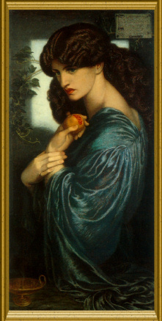

- The story of Persephone tells the story of how summer and winter were created. Why do you think that Persephone was chosen to represent summer? Think about her gender, how she is described in the story and what comes to mind when you think of summer.

- How are the female characters in the story presented? What does this suggest about how women were seen and treated when the story was told? Do the female characters have power in the story?

- Look at the painting of Persephone on the right. How well does the painting capture the ideas of the story? Think about the use of light and dark, Persephone’s emotions and anything else you can see in the picture.
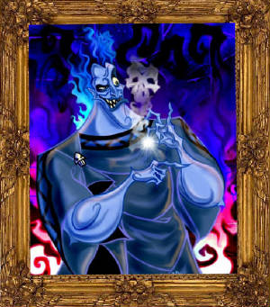
Task 2: Hades kidnapped Persephone and took her to the underworld. As well as being attracted to her, why else do you think he might have wished to bring her with him to such a lonely and dark place?

Task 3: Cerberus, the three headed dog (below), was said to guard the gates of the underworld in Greek mythology. Why do you think this monster was chosen?
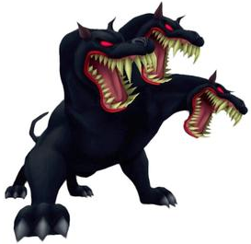
Task 4: Look at the picture of Cerberus.

- Bullet point 5 main aspects of Cerberus’ appearance that grab your attention (e.g. Claws).

- Write a paragraph describing Cerberus in detail.

Task 5: In some stories from Ancient Greece, mythical heroes would travel to the underworld in order to fulfil missions, but would always successfully escape. What do you think this showed about the hero?
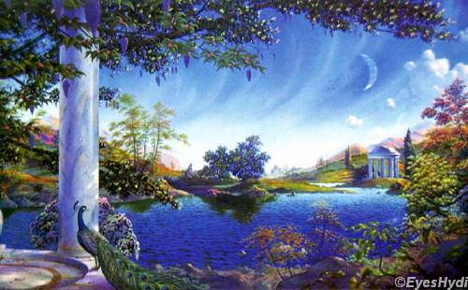
Whereas the underworld was created to be a horrible place, the opposite called The Elysian Fields (in Greek mythology) was supposed to be a paradise.

Task 6: Look at the picture showing The Elysian Fields on the right. Describe what you can see and make it sound like the perfect place to be.

Task 7: People either went to the underworld or the Elysian Fields when they died depending whether they were good or bad. How would this encourage people to be good?

Task 8: Read the Japanese creation story below…
Long ago all the elements were mixed together with one germ of life. This germ began to mix things around and around until the heavier part sank and the lighter part rose. A muddy sea that covered the entire earth was created. From this ocean grew a green shoot. It grew and grew until it reached the clouds and there it was transformed into a god. Soon this god grew lonely and it began to create other gods. The last two gods it made, Izanagi anf Izanami, were the most remarkable.
One day as they were walking along they looked down on the ocean and wondered what was beneath it. Izanagi thrust his staff into the waters and as he pulled it back up some clumps of mud fell back into the sea. They began to harden and grow until they became the islands of Japan.
The two descended to these islands and began to explore, each going in different directions. They created all kinds of plants. When they met again they decided to marry and have children to inhabit the land. The first child Izanami bore was a girl of radiant beauty. The gods decided she was too beautiful to live in Japan, so they put her up in the sky and she became the sun. Their second daughter, Tsuki-yami, became the moon and their third and unruly son, Sosano-wo, was sentenced to the sea, where he creates storms.
Later, their first child, Amaterasu, bore a son who became the emperor of Japan and all the emperors since then have claimed descent from him.

- Look at how the females are presented in the Japanese creation story. How is this similar/different to how Persephone is presented in the Greek story?
- Can you see any similarities between how Hades is presented and how Sosano-wo (the storm making son from the Japanese story) is described?
- Write a diary entry as Sosano-wo, describing how he feels about being sentenced to spend all his life living in the sea (try to make him sound like a ‘stroppy’ teenager in your writing).
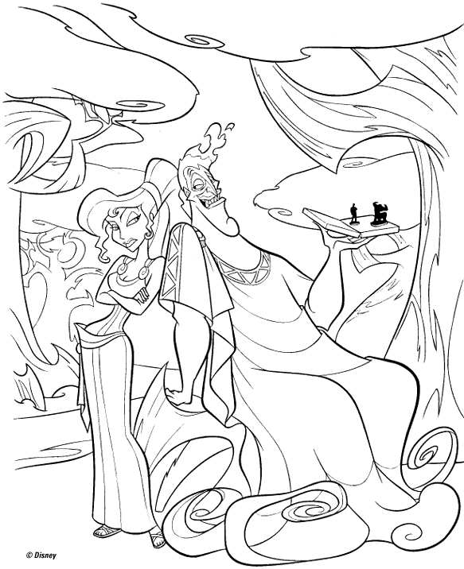
Task 9: Using half a page, design one of the following:
- A creature to guard an underworld
- A creature to guard a paradise/heavenly place
- A beautiful/good goddess
- A bad and mischievous god

Task 10: The bullet points below contain some random words. Using as many of these random words as possible, come up with your own creation story (using the story of Persephone and the Japanese creation story to help you) for a mythical place.
- A fish
- A squirrel
- Stars
- A moon
- A plant
- Clay
- Sea
- Sky

Extension (G+T question): Many creation stories make reference to the idea of balance. Look at the symbol on the left. How do you think it could relate to the creation stories that you have looked at and any others you may know?

